CHAPTER 4
4. Measures of Dispersion (Variation)

Introduction and objectives of measuring Variation

The scatter or spread of items of a distribution is known as dispersion or variation. In other words the degree to which numerical data tend to spread about an average value is called dispersion or variation of the data.
Measures of dispersions are statistical measures which provide ways of measuring the extent in which data are dispersed or spread out.
Objectives of measuring Variation:
- To judge the reliability of measures of central tendency
- To control variability itself.
- To compare two or more groups of numbers in terms of their variability.
- To make further statistical analysis.
Absolute and Relative Measures of Dispersion
The measures of dispersion which are expressed in terms of the original unit of a series are termed as absolute measures. Such measures are not suitable for comparing the variability of two distributions which are expressed in different units of measurement and different average size. Relative measures of dispersions are a ratio or percentage of a measure of absolute dispersion to an appropriate measure of central tendency and are thus pure numbers independent of the units of measurement. For comparing the variability of two distributions (even if they are measured in the same unit), we compute the relative measure of dispersion instead of absolute measures of dispersion.
Types of Measures of Dispersion

Various measures of dispersions are in use. The most commonly used measures of dispersions are:
- Range and relative range
- Quartile deviation and coefficient of Quartile deviation
- Mean deviation and coefficient of Mean deviation
- Standard deviation and coefficient of variation.

The Range (R)
The range is the largest score minus the smallest score. It is a quick and dirty measure of variability, although when a test is given back to students they very often wish to know the range of scores. Because the range is greatly affected by extreme scores, it may give a distorted picture of the scores. The following two distributions have the same range, 13, yet appear to differ greatly in the amount of variability.
Distribution 1: | 32 | 35 | 36 | 36 | 37 | 38 | 40 | 42 | 42 | 43 | 43 | 45
Distribution 2: | 32 | 32 | 33 | 33 | 33 | 34 | 34 | 34 | 34 | 34 | 35 | 45
For this reason, among others, the range is not the most important measure of variability.
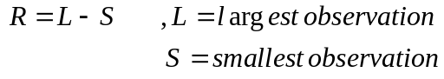
Range for grouped data:
If data are given in the shape of continuous frequency distribution, the range is computed as:
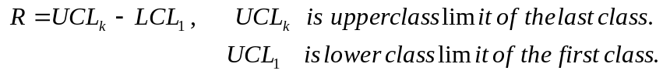

This is some times expressed as:
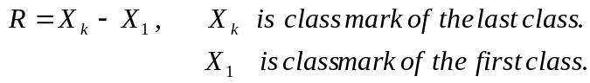
Merits and Demerits of range
Merits:
- It is rigidly defined.
- It is easy to calculate and simple to understand.
Demerits:
- It is not based on all observation.
- It is highly affected by extreme observations.
- It is affected by fluctuation in sampling.
- It is not liable to further algebraic treatment.
- It can not be computed in the case of open end distribution.
- It is very sensitive to the size of the sample.
Relative Range (RR)
it is also sometimes called coefficient of range and given by:
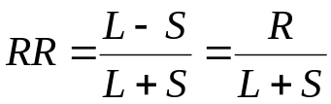
Example:
- Find the relative range of the above two distribution.(exercise!)
- If the range and relative range of a series are 4 and 0.25 respectively. Then what is the value of:
  - Smallest observation
  - Largest observation
Solutions :( 2)
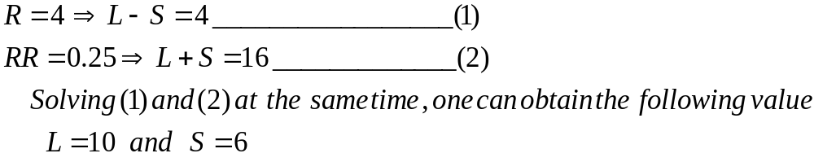

The Quartile Deviation (Semi-inter quartile range), Q.D

The inter quartile range is the difference between the third and the first quartiles of a set of items and semi-inter quartile range is half of the inter quartile range.
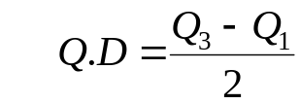
Coefficient of Quartile Deviation (C.Q.D)

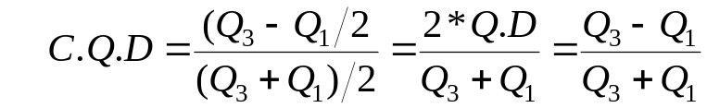

- It gives the average amount by which the two quartiles differ from the median.

Example: Compute Q.D and its coefficient for the following distribution.

Values | Frequency
140- 150 | 17
150- 160 | 29
160- 170 | 42
170- 180 | 72
180- 190 | 84
190- 200 | 107
200- 210 | 49
210- 220 | 34
220- 230 | 31
230- 240 | 16
240- 250 | 12

Solutions:
In the previous chapter we have obtained the values of all quartiles as:
Q₁= 174.90, Q₂= 190.23, Q₃=203.83

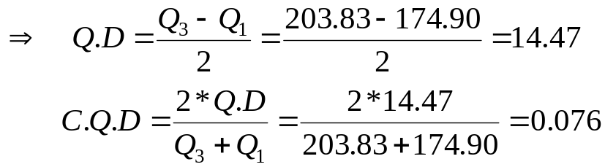

Remark: Q.D or C.Q.D includes only the middle 50% of the observation.

The Mean Deviation (M.D):

The mean deviation of a set of items is defined as the arithmetic mean of the values of the absolute deviations from a given average. Depending up on the type of averages used we have different mean deviations.
- Mean Deviation about the mean
- Denoted by M.D(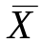) and given by
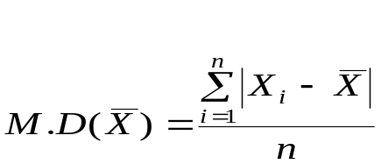
- For the case of frequency distribution it is given as:
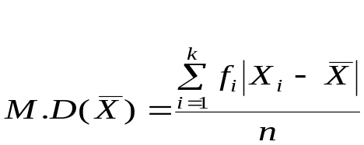

Steps to calculate M.D ():
- Find the arithmetic mean,
- Find the deviations of each reading from.
- Find the arithmetic mean of the deviations, ignoring sign.

- Mean Deviation about the median.
  - Denoted by M.D(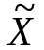) and given by
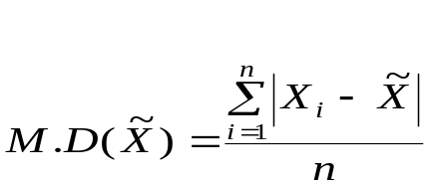
  - For the case of frequency distribution it is given as:

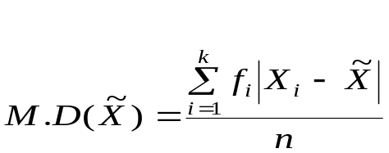 Steps to calculate M.D ():
- Find the median,
- Find the deviations of each reading from.
- Find the arithmetic mean of the deviations, ignoring sign.

- Mean Deviation about the mode.
  - Denoted by M.D(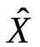) and given by

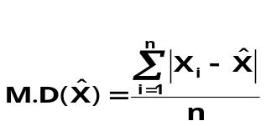

  - For the case of frequency distribution it is given as:

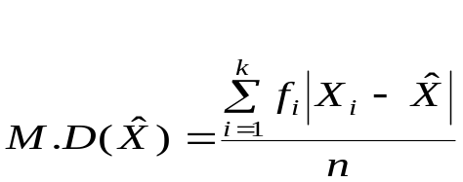

Steps to calculate M.D (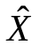):
- Find the mode,
- Find the deviations of each reading from.
- Find the arithmetic mean of the deviations, ignoring sign.

Examples:
- The following are the number of visit made by ten mothers to the local doctor’s surgery. 8, 6, 5, 5, 7, 4, 5, 9, 7, 4
Find mean deviation about mean, median and mode.
Solutions:
First calculate the three averages
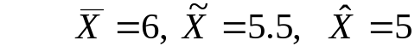

Then take the deviations of each observation from these averages.
X_{i} | 4 | 4 | 5 | 5 | 5 | 6 | 7 | 7 | 8 | 9 | total
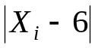 | 2 | 2 | 1 | 1 | 1 | 0 | 1 | 1 | 2 | 3 | 14
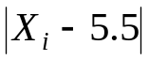 | 1.5 | 1.5 | 0.5 | 0.5 | 0.5 | 0.5 | 1.5 | 1.5 | 2.5 | 3.5 | 14
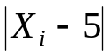 | 1 | 1 | 0 | 0 | 0 | 1 | 2 | 2 | 3 | 4 | 14

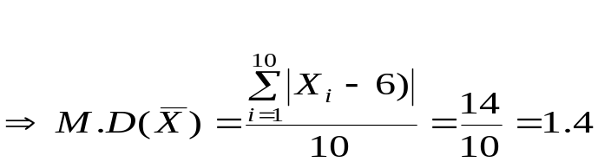
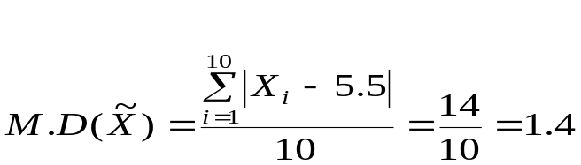
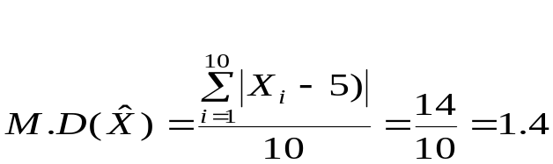

- Find mean deviation about mean, median and mode for the following distributions.(exercise)

Class | Frequency
40-44 | 7
45-49 | 10
50-54 | 22
55-59 | 15
60-64 | 12
65-69 | 6
70-74 | 3

Remark: Mean deviation is always minimum about the median.

Coefficient of Mean Deviation (C.M.D)

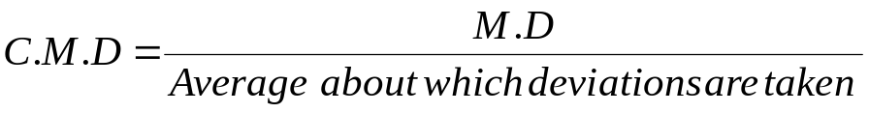

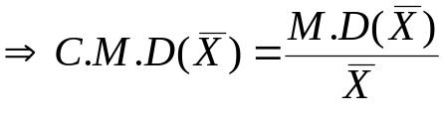
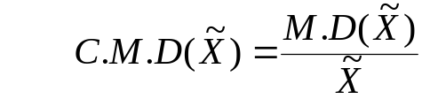
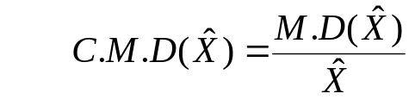
Example: calculate the C.M.D about the mean, median and mode for the data in example 1 above.

Solutions:

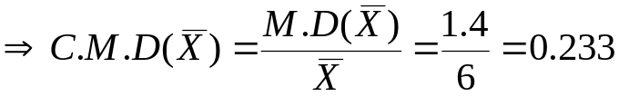
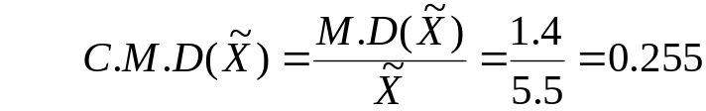
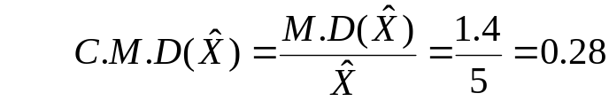
Exercise: Identify the merits and demerits of Mean Deviation

The Variance
Population Variance
If we divide the variation by the number of values in the population, we get something called the population variance. This variance is the "average squared deviation from the mean".
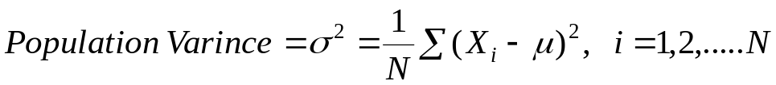
For the case of frequency distribution it is expressed as:
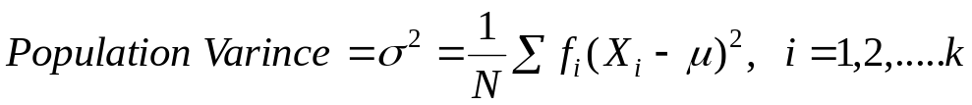
Sample Variance
One would expect the sample variance to simply be the population variance with the population mean replaced by the sample mean. However, one of the major uses of statistics is to estimate the corresponding parameter. This formula has the problem that the estimated value isn't the same as the parameter. To counteract this, the sum of the squares of the deviations is divided by one less than the sample size.
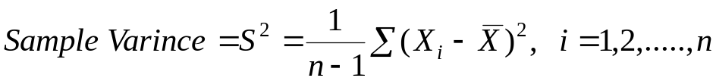
For the case of frequency distribution it is expressed as:
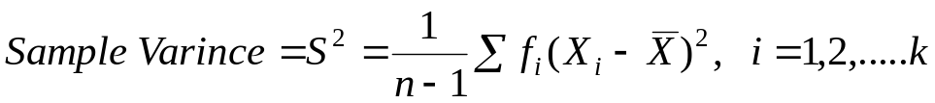
We usually use the following short cut formula.
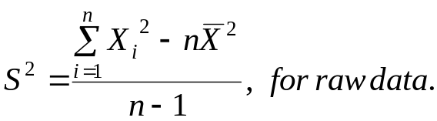
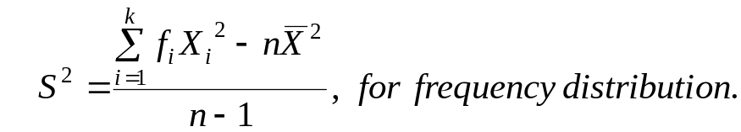

Standard Deviation
There is a problem with variances. Recall that the deviations were squared. That means that the units were also squared. To get the units back the same as the original data values, the square root must be taken.
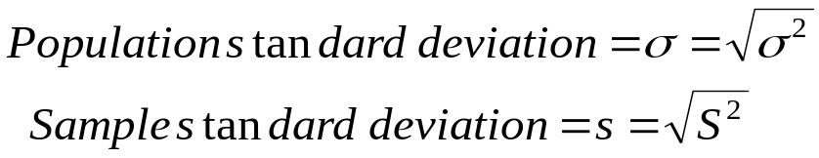
The following steps are used to calculate the sample variance:
1. Find the arithmetic mean.
2. Find the difference between each observation and the mean.
3. Square these differences.
4. Sum the squared differences.
5. Since the data is a sample, divide the number (from step 4 above) by the number of observations minus one, i.e., n-1 (where n is equal to the number of observations in the data set).

Examples: Find the variance and standard deviation of the following sample data
- 5, 17, 12, 10.
- The data is given in the form of frequency distribution.
Class | Frequency
40-44 | 7
45-49 | 10
50-54 | 22
55-59 | 15
60-64 | 12
65-69 | 6
70-74 | 3
Solutions:
- 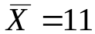

X_{i} | 5 | 10 | 12 | 17 | Total
(X_{i}- 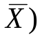² | 36 | 1 | 1 | 36 | 74

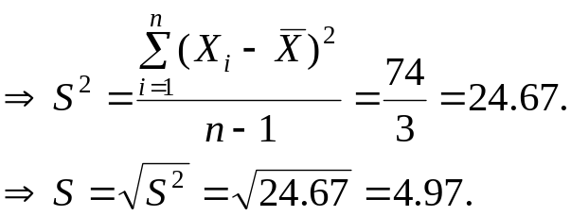

- 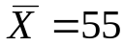
X_{i}(C.M) | 42 | 47 | 52 | 57 | 62 | 67 | 72 | Total
f_{i}(X_{i}- ² | 1183 | 640 | 198 | 60 | 588 | 864 | 867 | 4400

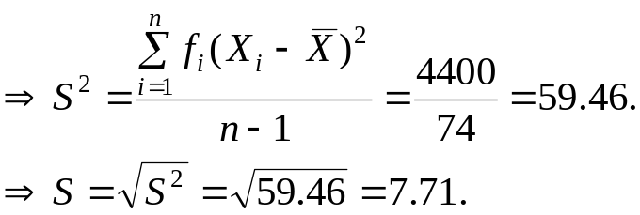

Special properties of Standard deviations

- 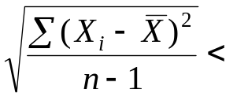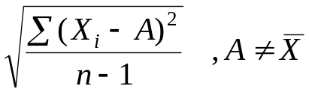
- For normal (symmetric distribution the following holds.
  - Approximately 68.27% of the data values fall within one standard deviation of the mean. i.e. with in 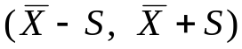
  - Approximately 95.45% of the data values fall within two standard deviations of the mean. i.e. with in 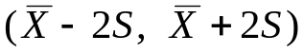
  - Approximately 99.73% of the data values fall within three standard deviations of the mean. i.e. with in 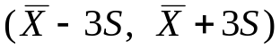

- Chebyshev's Theorem
For any data set ,no matter what the pattern of variation, the proportion of the values that fall with in k standard deviations of the mean or 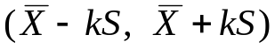 will be at least 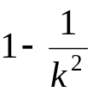, where k is an number greater than 1. i.e. the proportion of items falling beyond k standard deviations of the mean is at most 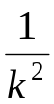
Example: Suppose a distribution has mean 50 and standard deviation 6.What percent of the numbers are:
- Between 38 and 62
- Between 32 and 68
- Less than 38 or more than 62.
- Less than 32 or more than 68.

Solutions:

- 38 and 62 are at equal distance from the mean,50 and this distance is 12
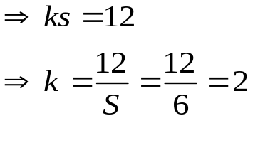
➔ Applying the above theorem at least 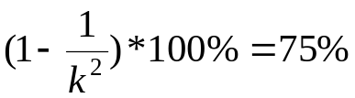 of the numbers lie between 38 and 62.

- Similarly done.
- It is just the complement of a) i.e. at most 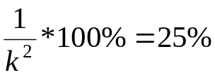 of the numbers lie less than 32 or more than 62.
- Similarly done.

Example 2:
The average score of a special test of knowledge of wood refinishing has a mean of 53 and standard deviation of 6. Find the range of values in which at least 75% the scores will lie. (Exercise)

- If the standard deviation of 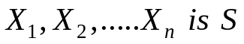, then the standard deviation of
- 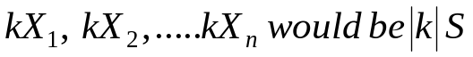
Exercise: Verify each of the above relation ship, considering k and a as constants.

Examples:
- The mean and standard deviation of n Tetracycline Capsules 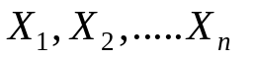 are known to be 12 gm and 3 gm respectively. New set of capsules of another drug are obtained by the linear transformation Y_{i} = 2X_{i} – 0.5 ( i = 1, 2, …, n ) then what will be the standard deviation of the new set of capsules
- The mean and the standard deviation of a set of numbers are respectively 500 and 10.
  - If 10 is added to each of the numbers in the set, then what will be the variance and standard deviation of the new set?
  - If each of the numbers in the set are multiplied by -5, then what will be the variance and standard deviation of the new set?
Solutions:
- Using c) above the new standard deviation =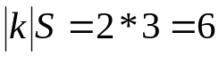
- a. They will remain the same.
b. New standard deviation=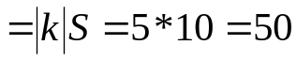

Coefficient of Variation (C.V)

- Is defined as the ratio of standard deviation to the mean usually expressed as percents.
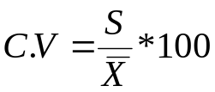
- The distribution having less C.V is said to be less variable or more consistent.
Examples:
- An analysis of the monthly wages paid (in Birr) to workers in two firms A and B belonging to the same industry gives the following results

Value | Firm A | Firm B
Mean wage | 52.5 | 47.5
Median wage | 50.5 | 45.5
Variance | 100 | 121

In which firm A or B is there greater variability in individual wages?

Solutions:
Calculate coefficient of variation for both firms.
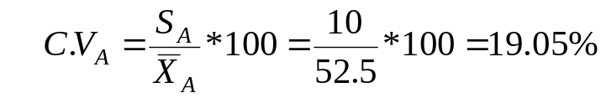
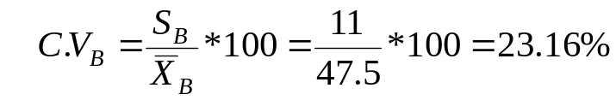
Since C.V_{A} < C.V_{B}, in firm B there is greater variability in individual wages.
- A meteorologist interested in the consistency of temperatures in three cities during a given week collected the following data. The temperatures for the five days of the week in the three cities were
City 1 | 25 | 24 | 23 | 26 | 17
City2 | 22 | 21 | 24 | 22 | 20
City3 | 32 | 27 | 35 | 24 | 28
Which city have the most consistent temperature, based on these data?
(Exercise)
Standard Scores (Z-scores)

  - If X is a measurement from a distribution with mean and standard deviation S, then its value in standard units is

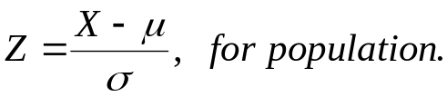

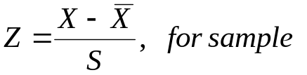
  - Z gives the deviations from the mean in units of standard deviation
  - Z gives the number of standard deviation a particular observation lie above or below the mean.
  - It is used to compare two observations coming from different groups.
Examples:
- Two sections were given introduction to statistics examinations. The following information was given.

Value | Section 1 | Section 2
Mean | 78 | 90
Stan.deviation | 6 | 5

Student A from section 1 scored 90 and student B from section 2 scored 95.Relatively speaking who performed better?

Solutions:
Calculate the standard score of both students.
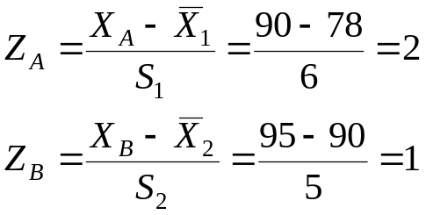
➔ Student A performed better relative to his section because the score of student A is two standard deviation above the mean score of his section while, the score of student B is only one standard deviation above the mean score of his section.
- Two groups of people were trained to perform a certain task and tested to find out which group is faster to learn the task. For the two groups the following information was given:

Value | Group one | Group two
Mean | 10.4 min | 11.9 min
Stan.dev. | 1.2 min | 1.3 min
Relatively speaking:
- Which group is more consistent in its performance
- Suppose a person A from group one take 9.2 minutes while person B from Group two take 9.3 minutes, who was faster in performing the task? Why?

Solutions:
- Use coefficient of variation.
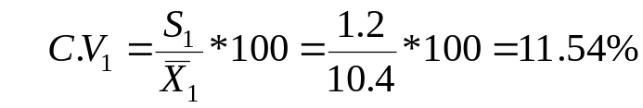
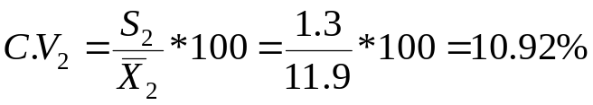
Since C.V₂ < C.V₁, group 2 is more consistent.
- Calculate the standard score of A and B

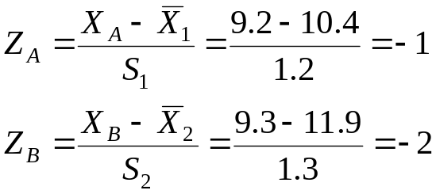
➔Child B is faster because the time taken by child B is two standard deviation shorter than the average time taken by group 2 while, the time taken by child A is only one standard deviation shorter than the average time taken by group 1.

Moments
- If X is a variable that assume the values X₁, X₂,…..,X_{n} then
- The r^{th} moment is defined as:
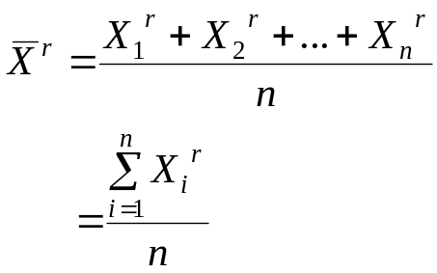
- For the case of frequency distribution this is expressed as:

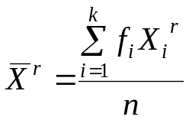
- If 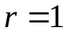,it is the simple arithmetic mean, this is called the first moment.

- The r^{th} moment about the mean ( the r^{th} central moment)

- Denoted by M_{r} and defined as:
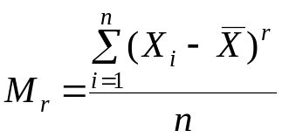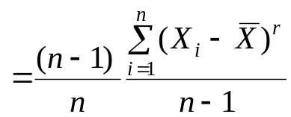
- For the case of frequency distribution this is expressed as:

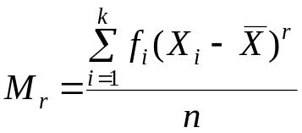
- If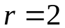, it is population variance, this is called the second central moment. If we assume 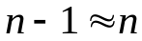 ,it is also the sample variance.

- The r^{th} moment about any number A is defined as:

- Denoted by 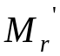and
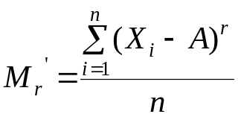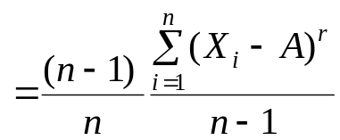
- For the case of frequency distribution this is expressed as:

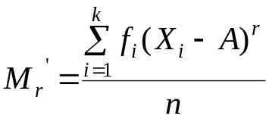

Example:
- Find the first two moments for the following set of numbers 2, 3, 7
- Find the first three central moments of the numbers in problem 1
- Find the third moment about the number 3 of the numbers in problem 1.
Solutions:
- Use the r^{th} moment formula.
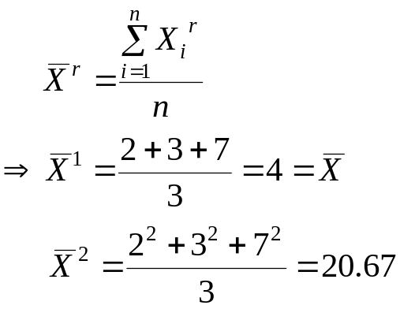

- Use the r^{th} central moment formula.
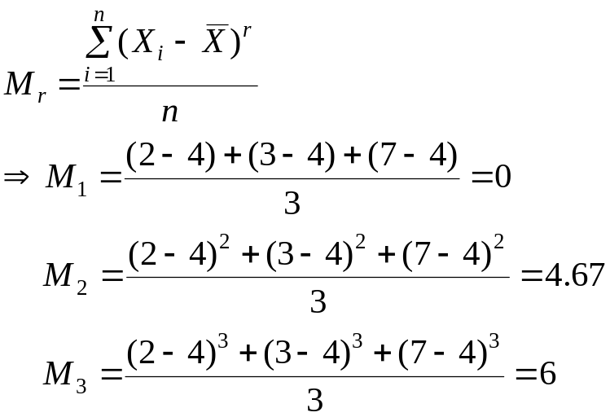

- Use the r^{th} moment about A.

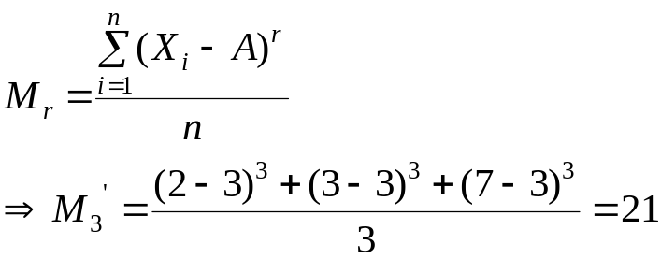

Skewness

- Skewness is the degree of asymmetry or departure from symmetry of a distribution.
- A skewed frequency distribution is one that is not symmetrical.
- Skewness is concerned with the shape of the curve not size.
- If the frequency curve (smoothed frequency polygon) of a distribution has a longer tail to the right of the central maximum than to the left, the distribution is said to be skewed to the right or said to have positive skewness. If it has a longer tail to the left of the central maximum than to the right, it is said to be skewed to the left or said to have negative skewness.
- For moderately skewed distribution, the following relation holds among the three commonly used measures of central tendency.

Measures of Skewness
- Denoted by 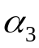
- There are various measures of skewness.
- The Pearsonian coefficient of skewness
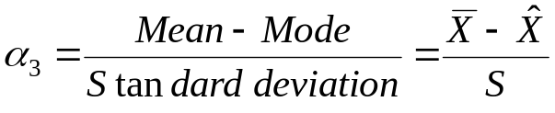
- The Bowley’s coefficient of skewness ( coefficient of skewness based on quartiles)
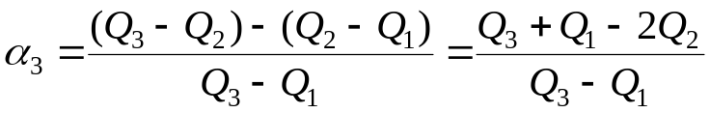
- The moment coefficient of skewness
The shape of the curve is determined by the value of

Remark:
    - In a positively skewed distribution, smaller observations are more frequent than larger observations. i.e. the majority of the observations have a value below an average.
    - In a negatively skewed distribution, smaller observations are less frequent than larger observations. i.e. the majority of the observations have a value above an average.

Examples:
- Suppose the mean, the mode, and the standard deviation of a certain distribution are 32, 30.5 and 10 respectively. What is the shape of the curve representing the distribution?
Solutions:
Use the Pearsonian coefficient of skewness
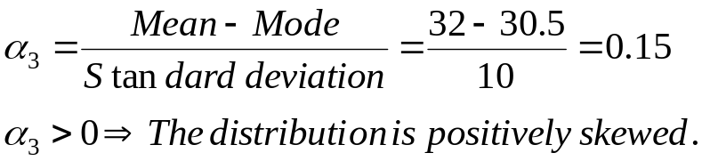
- In a frequency distribution, the coefficient of skewness based on the quartiles is given to be 0.5. If the sum of the upper and lower quartile is 28 and the median is 11, find the values of the upper and lower quartiles.
Solutions:
Given: 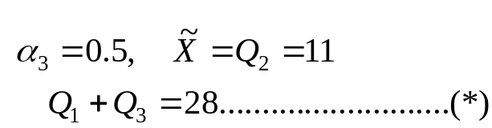 Required: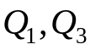

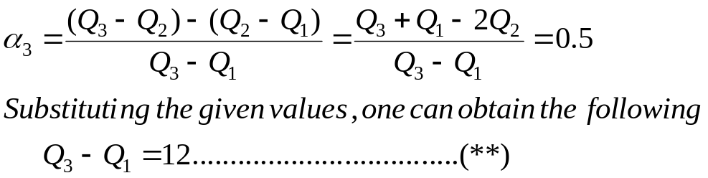

- Some characteristics of annually family income distribution (in Birr) in two regions is as follows:
Region | Mean | Median | Standard Deviation
A | 6250 | 5100 | 960
B | 6980 | 5500 | 940
- Calculate coefficient of skewness for each region
- For which region is, the income distribution more skewed. Give your interpretation for this Region
- For which region is the income more consistent?

Solutions: (exercise)

- For a moderately skewed frequency distribution, the mean is 10 and the median is 8.5. If the coefficient of variation is 20%, find the Pearsonian coefficient of skewness and the probable mode of the distribution. (exercise)

- The sum of fifteen observations, whose mode is 8, was found to be 150 with coefficient of variation of 20%
- Calculate the pearsonian coefficient of skewness and give appropriate conclusion.
- Are smaller values more or less frequent than bigger values for this distribution?
- If a constant k was added on each observation, what will be the new pearsonian coefficient of skewness? Show your steps. What do you conclude from this?
Solutions: (exercise)

Kurtosis

Kurtosis is the degree of peakdness of a distribution, usally taken relative to a normal distribution. A distribution having relatively high peak is called leptokurtic. If a curve representing a distribution is flat topped, it is called platykurtic. The normal distribution which is not very high peaked or flat topped is called mesokurtic.
Measures of kurtosis
The moment coefficient of kurtosis:
- Denoted by 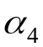 and given by
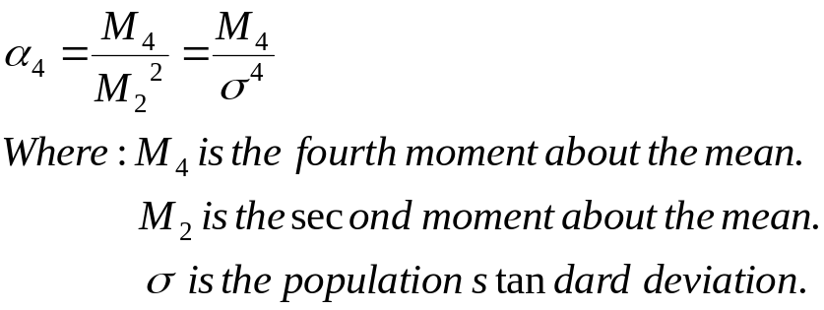
The peakdness depends on the value of.
Examples:
  - If the first four central moments of a distribution are:
    - Compute a measure of skewness
    - Compute a measure of kurtosis and give your interpretation.

Solutions:
- 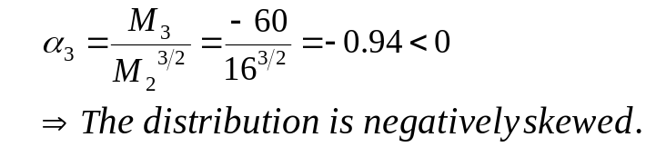

- 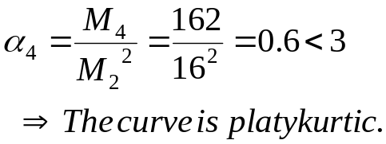

  - The median and the mode of a mesokurtic distribution are 32 and 34 respectively. The 4th moment about the mean is 243. Compute the Pearsonian coefficient of skewness and identify the type of skewness. Assume (n-1 = n).

  - If the standard deviation of a symmetric distribution is 10, what should be the value of the fourth moment so that the distribution is mesokurtic?
Solutions (exercise).

